Handled by / Version Offer date Revision date Offer number
Dhananjay kale 25/09/17 01 368/09/17

Customer Reference

NIHVA’
Pune-.
Subject:-
Pillar mounting manipulator
Contact person
SIR
Customer’s Tel.
Customer’s Fax.

Dear Sirs,

Thank you for your enquiry and we are pleased to submit our Final Offer for your consideration.

The following documents are attached to this Offer and form an integral part thereof:
- Commercial Terms
Please review this offer, literature carefully. We trust our offer meets with your requirement; however, should you require further information, please do not hesitate to contact us. We appreciate this opportunity to be of service on your materials processing requirements and are confident that we have offered equipment that meet and exceed your expectations. We look forward to receiving your valued order.

Yours faithfully,
Dkk services
_______________________________

Mobile: +919890270005
Email:- dkkservices @gmail.com

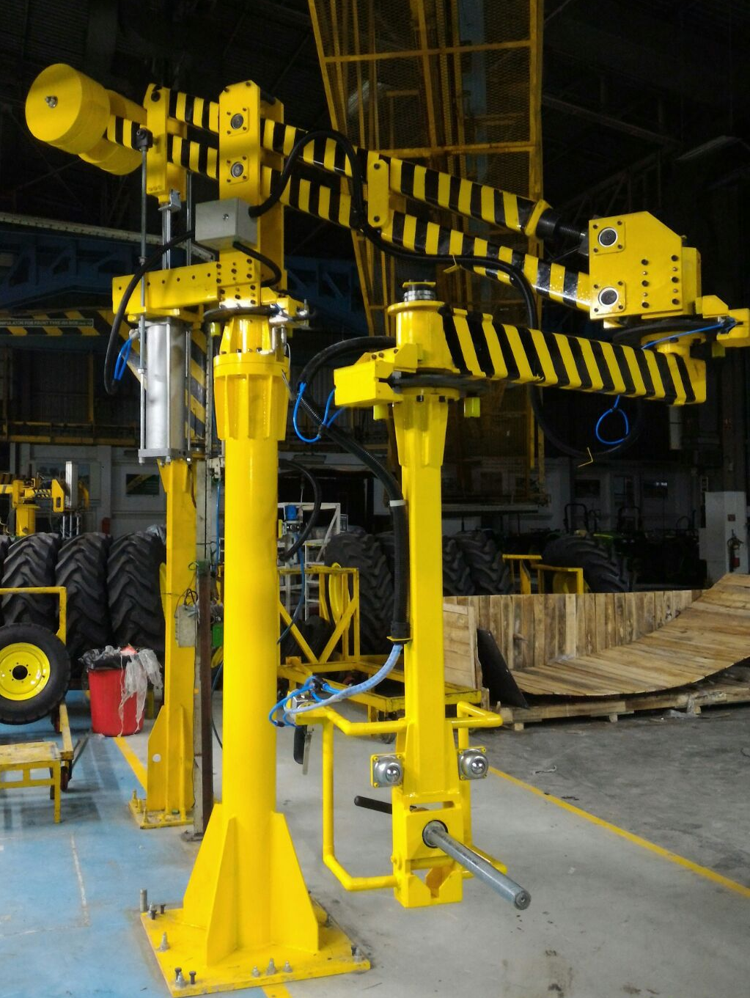

1 COMMERCIAL TERMS

1.1 Scope of supply and Pricing Summary

Item Description Cus. Reference Cur. Price
No Seller’s reference (EACH qty)
- Pneumatic pillar Mounting Manipulator 150kg 700,000/-
2 Gripper pneumatic - Existing Gripper use 380000/-
3 Installation 50,000/-
4 Air booster and Dryer 125000/-

Size
Frist Arm -1.6 mtr
2nd arm -1.2 mtr

TOTAL PRICE: Rs 830,000/-
[Excluding Taxes]
The scope of supply for each item is specified in more detail in our offer and the enclosed Technical Specification (Annexure 2)
I

B) Scope of supply:
To design, manufacture, supply & install manipulator

Content of the system:
2. Articulated arm type manipulator with zero gravity pneu. Circuit.
3. Pneumatic gripper.
4. Operator pendant with push buttons.
5. Parking brakes for all rotary joints. (3 nos.)
6. Spiral pneu. Tubing with brackets for mounting.
7. FR unit.
Technical details of the components:
Sr. no.
Component
Variant
Weight (Kg.) -300kg
Application
Location
1. Manipulator (Articulating arms) specification – DKK-300
a. Load capacity – 300 Kg (Gripper + component) – at 6 bars.
b. Working radius – Approximately 2.8meters (layout based)
A detailed layout will be drafted for the fixture station. Based on kinematic design,
the working reach and radius will be defined and decided.
c. Lifting stroke (Vertical stroke) –800 mm
d. Rotation around main bearing joint on trolley, secondary rotation joint at
horizontal arm, and final vertical gripper arm.
e. Brakes at rotary joint– Brakes actuate in case of loss of air.
f. Balance control – Manually adjustable balance control. Special balancing control
knob, which will be located close to operator hand, for fine setting of balance
during handling. Change over from load to no-load condition and vice versa will
be fully automatic.
g. Safety features – Standard safety features
I. In case of loss of air, component will not get released, in case of false
operation of release switch, equipment first comes down to find a surface
and then de-clamps.
II. No sudden jerks incase of sudden pressure rise or fall (or loss of air).
III. Component remains in clamped condition though there is a loss of air supply.
Process sequence –
1. parts available on pallet/table.
2. Operator will pick the assembly from pallet or table with manipulator gripper.
3. Clamping through manual push button. Tilting the same manually.
4. Operator will lift the component easily through ergonomic designed handle.
5. Operator will move the component along with gripper at the required position,
align and fix the same.
6. Ensuring primary locating & fixing at the desired position, operator will push de-
clamping button.
7. After de-clamping operator will move the gripper away from the place and will
park the system at pre-described parking position.
8. After parking, operator will perform tightening operation by his normal method.
This cycle will repeat after certain time interval for whole shift.

Gripper –

Will be designed and developed as per the process and component design. Zero gravity
control will be set at easy Handling as per the variants of the components. It is one time
setting and should not be change by client. If there are more than 3 variants,
uses special knob type regulator or selector switch for load stages, if required.
The arrangement will be like motorcycle accelerator and can be performed online during
insertion or any other operation of manipulator.
1.1 Function and description of the load assist:
Mechanical configurations –
The load assist is a pneumatic manipulator, which is similar in construction and
function of a human arm. With the main rotary bearing, the coupler bearings, the
parallelogram, the horizontal and vertical swivel arms, and the customized gripper, the
equipment exceeds the human degrees of freedom.
The handling equipment is available as a column mounted, overhead mounted or
overhead travelling trolley mounted versions. The lifting height and the working radius
are set as per layout and application.
The mechanical assembly is entirely modular in construction. The lifting arm and
swivel arms are manufactured from high quality rectangular tubes, with high torsion
resistance and minimal bending moment upon lifting of loads. The load is balanced by a
specially designed pneumatic cylinder, which slides parallel to its orientation thus
maintaining a cosine function.
The form of the swivel arms (horizontal and vertical) are modified as per the
application. For easy assembly of any type of gripper, the vertical swivel arm has at its
end an easy attachment flange.

Additionally, two springs actuated pneumatic brakes are provided with
the handling equipment. The equipment can be locked in position by the operator. In an
unavoidable event of failure of air supply, the brakes engage automatically to lock the
equipment in position.
brake
Air & Spring actuated fail safe strong
brakes at every rotary joint.
The air supply to the equipment should be through a filter-regulator unit. For better life
and working of the equipment clean and dry air should be used.
All components that go into manufacturing and assembly of the products, are well tested
and from reliable sources. Their quality, availability and long term supply is guaranteed.
1.2 Function of the Load assist–
The load assist is pneumatic handling equipment which achieves its optimal
efficiency at the air pressure of 6 bars. Using a load assist, the load shifts into a
weightless status in its entire working area. The work can be moved by an integrated
parallelogram rigid system, and can be swayed freely into three dimensional spaces.
The lifting and lowering of the load takes place as the operator moves the load up and
down. There is no requirement of pressing UP or DOWN switches, the equipment and
the load is in PERFECT balance stage (Zero gravity).
The load assist has two main balance stages. One balance stage puts the
equipment into balance without the load. In this case the equipment can be moved into
position effortlessly, with no load. The other balance stage puts the equipment into
balance with the load gripped. Now the equipment can be moved effortlessly with load.

The balance stage with the load can be manually set with the help of a rotation
knob. The balance stage can be set so as to take loads till the maximum capacity. Once
the manual adjustment is done the equipment automatically balances loads.
balance2
balance1
1.2.1 Balance control.
Adjustment of balance with rotation knob for various loads.
Balance pressure
indicating gauge
Balance pressure
adjusting Knob

This type of balance control makes possible easy and quick handling of loads
with constant weights, uptil the maximum capacity of the equipment. The adjustment of
this balance pressure is done by a pressure regulating valve and is set for a particular
constant load that the equipment has to lift.
With a pneumatic gripper, the equipment goes into a state of balance,
automatically when a signal (by means of a simple push button) for “Clamping” the part
is given by the operator, and when the parts are securely clamped and sensed by means
of pneumatic limit switch
The “De-Clamping” of the load is not possible when the equipment is in hanging
condition along with the load. This is made possible with an additional pneumatic safety
circuitry.

1.3 Modules integrated into the gripper:

There are various modules integrated into a single working mechanism to form a
Gripper. Normally a Clamping module serves as a mechanism to clamp or hold the
component being lifted securely. Based on design the clamping module could be
mechanical, pneumatic. Tilting or swivel module – This enable
orientation change of the component from the position while picking and to position while
placing the component. Design each gripper is requirement based and is completely
tailor made for a specific application.

components – On a through and a detailed understanding of the handling requirement
and assembly process and components, grippers are developed by us using 3D CAD
tools. Various modules are integrated as per requirement of the process.

2.0 General guidelines related to the project

2.1 Assembly guidelines

The assembly and testing will be executed by our expert mechanics. This makes
you very certain, that you provide perfectly functioning handling equipment to the
production line. During the Installation and commissioning of the equipment we will need
a co-worker qualified by you for the assembly support, a crane or a fork lift truck with
appropriate working range and power connections. It will be very convenient for us if you
do the possible necessary preparation at the site before the installation and
commissioning.

Steel structure, I Beam etc. construction – All the necessary steel construction
will be the responsibility of the customer. Foundation for the equipment is considered in scope of the customer. All civil works are exclusions for this offer.

2.2 General regulations to the supply –
This is a binding offer from us after receipt of the necessary data from you. If any
modifications are required we request you to please provide them to us in writing well in
advance before the start of detail designing. If these modifications will lead to any extra
costs we will specify accordingly which have to be coordinated separately.
As our general procedure we use standard load assist as the basic equipment
and standard components. If you suggest us to use any specific make components, we
cannot predicate its performance nor can we guarantee the performance of those
components. Any extra costs developing and procuring such company preferred
components have to be assigned separately.

We are proposing all standard make pneumatic elements – from, SMC or
equivalent. There might be some special valves in the system. We guarantee availability
of such valves from our office in Pune. In case of grippers, it is recommended that
customer keeps spares of critical elements pertaining to the gripper. Normally spares
costs are 8-10% of equipment costs.

A clean and dry air supply, have to be provided at the place of installation
through a FRL unit. DRY Air is a must for these equipments. In case water content is
found inside the precision balancing regulator or the balancing cylinder, the warranty for
those parts becomes void.

2.2.1 Additional requirements for the project –
With the purchase order, we will require master pieces of all types of parts to be
handled and detail CAD data. Either we should be allowed to take the necessary
photographs, or you should arrange for a photographer to take digital photos of the
necessary areas where handling is to be done. It is possible to start the project only after
the receipt of the above.

For the process of designing as well as equipment testing master samples are a
must. We will need CAD drawings in 3D format and 2D format as well.

2.3 Acceptance specifications and testing

2.3.1 Testing
We will thoroughly test the equipment after manufacturing and assembly. Your
team may remain present during the testing.
During testing, we will have a standard Protocol sheet for the equipment. The
equipment will be manufactured as per our standard. Number of switches (if otherwise
separately specified) will be one for Clamping, one for de-clamping, selector switch for
pitching / indexing (if function available), selector switch for Brakes ON/OFF. All switches
will be either ofsmc make or equivalent. Additional switches or handles, or
modifications in our standard equipment will be at an extra cost. The Protocol sheet will
have separate column wherein we specify the modifications which come at an extra
costs and the same have to be agreed to by the customer.

2.3.2 Final inspection
A final inspection of the manipulator will take place following the in-house
customer acceptance.

2.3.3 Documentation (Operation & maintenance manuals)

With the handling equipment you will receive a complete documentation of the handling
equipment.
The documentation will consist of –
1. Assembling instructions ·
2. Function descriptions
3. Gripper system with parts lists (Assembly drawing only)
4. Load assist system with parts lists
5. Pneumatic diagrams 6. Spare part specification
2.4 General terms of payment and delivery:
Quotation:
The prices are in Indian Rupees, Ex-works, Pune.
Terms of payment:
As mentioned in terms and conditions below.
Delivery time:
After the clarification of the job you will receive a layout diagram with concept
drawing from us. After the return of the drawing the delivery time amounts to of
approximately 10 weeks. In total the delivery will be in around 14-16 weeks.
Installation and commissioning –
The installation will be carried out under the supervision of our trained personnel.
All necessary equipments for installation such as ladders, platforms, forklift trucks,
chains etc should be made available by the customer. All the necessary construction
work should be completed in time by the customer so that the installation work can be
started immediately after supply and can be carried out without interruption. The
foundations must be dry and the concrete must have hardened. If necessary, labour
have to be provided by the customer.

Supply:
The handling equipment will be transported into fixtures and packages.
Warranty: 12 months from a date of supply.

Spares parts: We recommend a very few wearing parts to be stocked as spares. These
include brake pads. As per customer's choice, the main cylinder and the main regulating
valve can also be included into spares list. The cost of such spares ranges around 8% -
10% of the total cost. A detailed spare part list along with detailed pricing can be worked out after the gripper is completely designed. (DAP)

Standard bought-outs items used in equipment:

1. Main balancing cylinder: DKK SERVICES make.
3. Pneumatic: SMC
4. Panels: Rittal/Eldon
5. Ball Bearings: SKF/FAG
6. Bush bearings: Igus.
7. Dragchain: Igus.

Requirement from customer –
- CAD models of all variants (with all parts and features existing at the time of
handling).
- CAD model of vehicle.
- Layout in 2D
- Actual vehicle and component for trials.

C) Terms & conditions:

1. Payment (Equipment): 30% advance with techno-commercial clear order. 20% after
DAP. 50% with taxes against pro-forma invoice.
2. Payment (installation & commissioning): 100% after successful installation at your
end.
3.GST: extra.
4. Packing:2% extra. Wooden box. No seaworthy packing considered.
5. Transportation: Extra
6. Delivery location:, Pune.
7. Unloading at your end: at your account.
8. Octroi: To your account.
9. Delivery: 10 to 12 weeks after DAP.
10. DAP: 3-4 weeks after getting all data.
11. Acceptance criteria to be decided at the time of DAP.
12. Deviation in any technical specifications including standard makes will be carried out
at extra cost.
13. The system is warranted against any mechanical defect for the period of 12 month
from the date of supply.
14. Inspection & trials: at our end only.
15. Installation & commissioning at site will be at dkk scope.
16. Warranty does not include any electrical & magnetic components.
17. Validity of quotation: 30 days.
18. Advance will not be return if order is cancel by any reason.

If you need any additional information, please feel free to contact us.

Assuring our best services always.

For DKK SERVICES

Dhananjay kale
M: 9890270005

